FSJ Awards Project Management

February 1, 2018

Authors: Jacqueline Forest, Jonah Cowan, Pierre (Shu-Jun) Lin, Dave Kotowicz

**Project Plan**

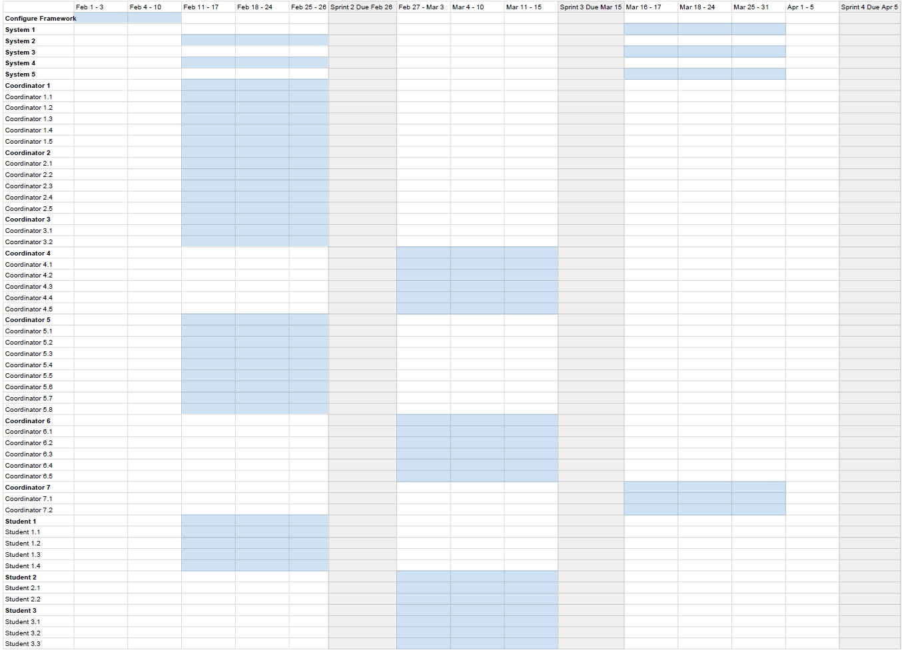

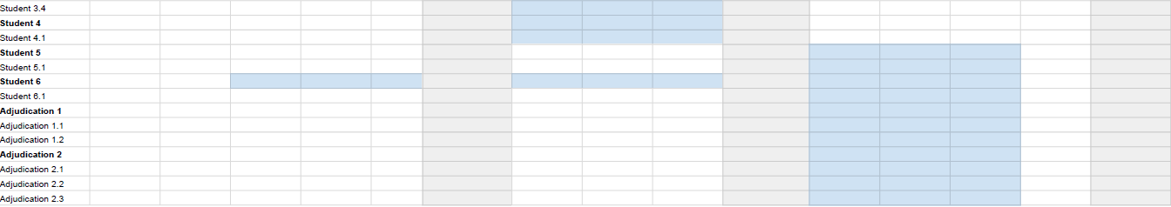

### Team Members’ Roles

|  |  |
| --- | --- |
| Task | Primary Responsibility |
| Configure Framework | Jacqueline, Jonah, Pierre, Dave |
| System 1 | Jonah |
| System 2 | Jacqueline |
| System 3 | Pierre |
| System 4 | Jacqueline |
| System 5 | Jonah |
| Coordinator 1 | Jonah |
| Coordinator 2 | Pierre |
| Coordinator 3 | Jonah |
| Coordinator 4 | Pierre |
| Coordinator 5 | Pierre |
| Coordinator 6 | Jacqueline |
| Coordinator 7 | Pierre |
| Student 1 | Dave |
| Student 2 | Dave |
| Student 3 | Jonah |
| Student 4 | Dave |
| Student 5 | Dave |
| Student 6 | Dave |
| Student 6.1 | Dave |
| Adjudication 1 | Jacqueline |
| Adjudication 2 | Jacqueline |